**Medical Clinic Database**

A patient with symptoms requests an appointment to be seen by a physician in a clinic. Patient needs to have an ID, address, insurance information, and phone number. Patient also needs to provide his/her medical records including record ID, test results, date of examination, previous diagnoses, medical issues, and allergies if any. Patient is admitted to a clinic that can be a general clinic or a special clinic with a certain address, reception, different departments, transportation services, billing section. In this clinic, medical doctors are practicing. Each doctor has a name, ID, contact information, specialty, department, and gender. This clinic also has provisions including diagnostics services, labs, X-ray services, MRI, and Ultrasound.

**The Functional Dependencies of the Database and Normalize the Schemas to 3NF**

Patient (Id, name, phone, address, insurance, symptoms)

(not even 1NF) 🡪 Patient (Street, City, State, Name, phone, insurance, symptoms, Id)

MedicalRecord (RecordId, drugs, previous diagnosis, allergies, problem, TestResult, data of examination, patientID)

FD1: Problem 🡪 previous diagnosis, allergies (transitive)

FD2: RecordID 🡪 problem, drug, patientID, Testresult ( full FD)

FD1: testResult◊data of examination, drug ( transitive)

problemInfo (problem, previous diagnosis, allergies)

RecordID (RecordID, problem, drug, patientID, Testresult)

TestResultInfo (testResult, data of examination, drug )

Provision (diagnostics services, lab, X-ray, MRI, ultrasound, address) (3NF)

Doctor (Id, gender, name, phone, department, address) (3NF)

Specialist Doctor (Id, specialist) (3NF)

Clinic (address, department, billing section, specialty, reception, transportation service)

(not even 1NF) ◊ (Street, City, State, department, billing section, specialty, reception, transportation service)

**Create and populate Medical Clinic database**

**(CREATE TABLE statements with appropriate constraints)**

drop table patient cascade constraints;

create table patient (

name varchar2(20) not null,

Id number(20) primary key not null,

address varchar2(20),

phone number(15),

insurance number(15),

symptoms varchar2(30));

insert into patient values('Nika', 34562,'22 Hanna',5013457651, 45678, 'fever');

insert into patient values('Sara', 234561,'22 Rossel',5013457652, 45695, 'headache');

insert into patient values('Rose', 234563,'22 Robinson',5013457655, 45697, 'vomiting');

insert into patient values('Sara', 234564,'24 kerby',5013457656, 45699, 'stomach pain');

insert into patient values('Li', 234565,'25 Mary',5013457657, 45694, 'diarrhea');

insert into patient values('Raha', 234566,'27 Main street',5013457658, 45693, 'constipation');

SELECT *

FROM patient;

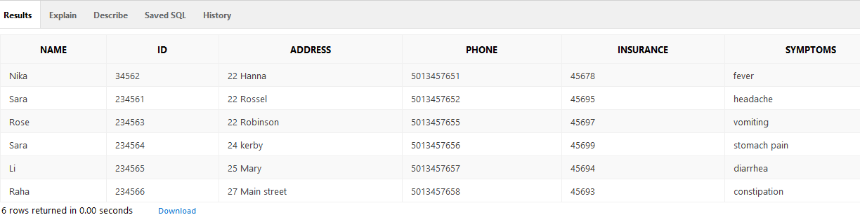

drop table problemInfo cascade constraints;

create table problemInfo (

problem varchar2(20) primary key,

previousDiagnosis varchar2(30),

allergies varchar2(20));

insert into problemInfo values ('kidney malfunction', 'high blood pressure', 'Penicillin');

insert into problemInfo values ('heart attack', 'myocardial artery stenosis', 'Peanuts');

insert into problemInfo values ('flu', 'cold', 'none');

insert into problemInfo values ('allergy', ' high blood pressure', 'none');

insert into problemInfo values ('constipation', ' high blood pressure', 'none');

insert into problemInfo values ('fatigue', 'high blood pressure', ' Peanuts ');

SELECT *

FROM problemInfo;

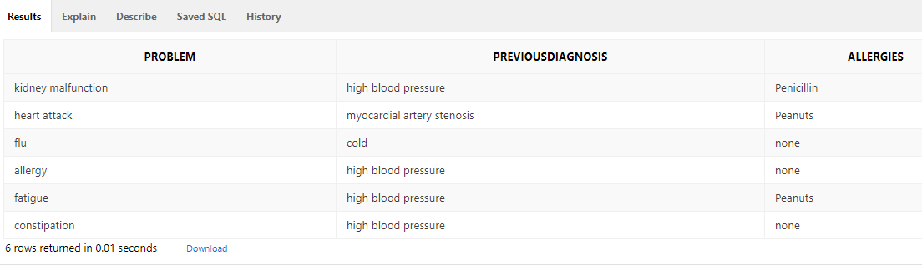

drop table testResultInfo cascade constraints;

create table testResultInfo (

testResult varchar2(20) primary key,

dataExamination varchar2(30),

drug varchar2(20));

insert into testResultInfo values ('high WBC', 'blood', 'Aspirin');

insert into testResultInfo values ('high blood sugar', 'blood', 'Metformin');

insert into testResultInfo values ('high LDL', 'blood', 'Atorvastatin');

insert into testResultInfo values ('high HCT', 'blood', ' Valsartan');

insert into testResultInfo values ('high creatinine', 'urine', ' antibiotics');

insert into testResultInfo values ('low HDL ', 'blood', ' niacin');

SELECT *

FROM testResultInfo;

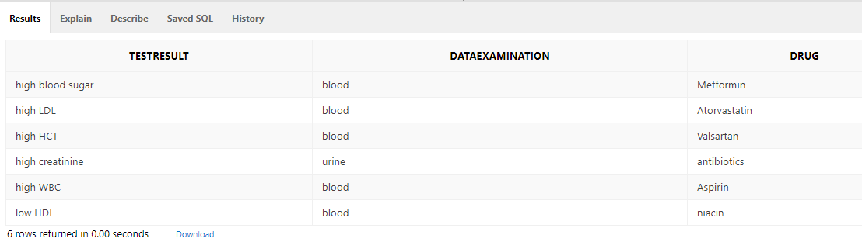

drop table clinic cascade constraints;

create table clinic (

address varchar2(20) primary key,

department varchar2(10),

billingSection varchar2(20),

specialty number(20),

reception varchar2(20),

transportationService varchar(15));

insert into clinic values ('12 Shuffield STE 11', 'Surgery', 'Heart', 34567, 'North Campus', 'NC transport');

insert into clinic values ('12 Shuffield STE 12', 'Radiology', 'Cancer', 34568, 'North Campus', 'NC transport');

insert into clinic values ('12 Shuffield STE 14', 'Pediatric', 'physical therapy', 34550, 'East Campus', 'EC transport');

insert into clinic values ('12 Shuffield STE 13', 'Pediatric', 'PICU', 34551, 'East Campus', 'EC transport');

insert into clinic values ('12 Shuffield STE 10', 'Urology', 'testing center', 34540, 'West Campus', 'WC transport');

insert into clinic values ('12 Shuffield STE 15', 'Radiology', 'X-ray', 34569, 'North Campus', 'NC transport');

SELECT *

FROM clinic;

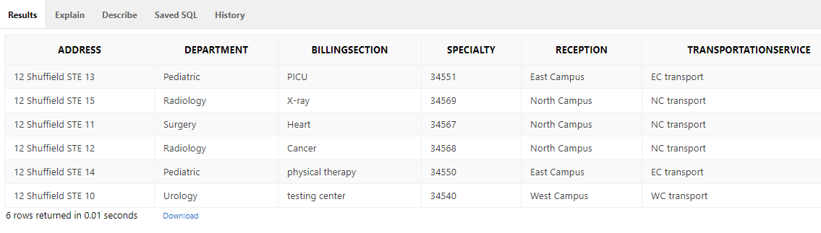

drop table patiantRecord cascade constraints;

create table patiantRecord (

recordID number(20) primary key,

problem varchar2(30) references problemInfo(problem),

drug varchar2(20),

patientID number(20) references patient(Id),

testResult varchar2(30) references testResultInfo(testResult));

insert into patiantRecord values (2345, 'kidney malfunction', 'Aspirin', 34562, 'high WBC');

insert into patiantRecord values (4563, 'heart attack', 'Vitamin C', 234561, 'high blood sugar');

insert into patiantRecord values (7895, 'flu', 'cold stop', 234563, 'high LDL');

insert into patiantRecord values (7896, 'allergy', ' benadryl ', 234564, 'high HCT');

insert into patiantRecord values (7897, 'constipation', 'MiraLAX Powder', 234566 , 'high creatinine');

insert into patiantRecord values (7898, 'fatigue', ' ADRENAL RESTORE', 234565, 'low HDL');

SELECT *

FROM patiantRecord;

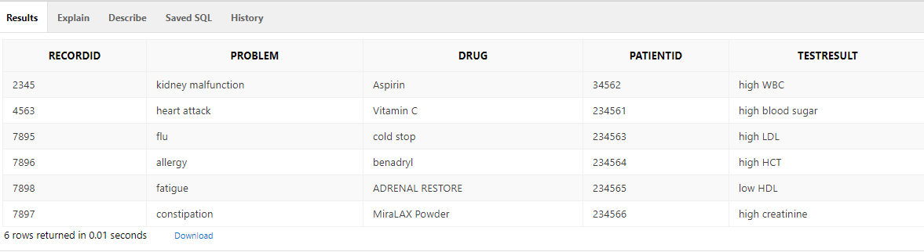

drop table provision cascade constraints;

create table provision (

diagnosticsServices varchar2(20) primary key,

lab varchar2(30),

Xray varchar2(20),

MRI varchar2(20),

ultrasound varchar2(20),

address varchar2(20) references clinic(address));

insert into provision values ('blood test', 'blood', 'fluoroscopy', 'T2 FLAIR', 'none', '12 Shuffield STE 11');

insert into provision values ('Radiology', 'none', 'PET/CT', 'T1', 'none', '12 Shuffield STE 12');

insert into provision values ('Stress test', 'blood', 'chest X-ray', 'non', 'echocardiography', '12 Shuffield STE 11');

insert into provision values ('lab test', 'urine', 'contrast dynamic','T1 post contrast', 'echo', '12 Shuffield STE 10');

insert into provision values ('blood glucose test', 'blood', 'PET/CT', 'T2 FLAIR', 'none', '12 Shuffield STE 11');

insert into provision values ('imagine', 'none', 'fluoroscopy', 'T2 FLAIR', 'none', '12 Shuffield STE 12');

SELECT *

FROM provision;

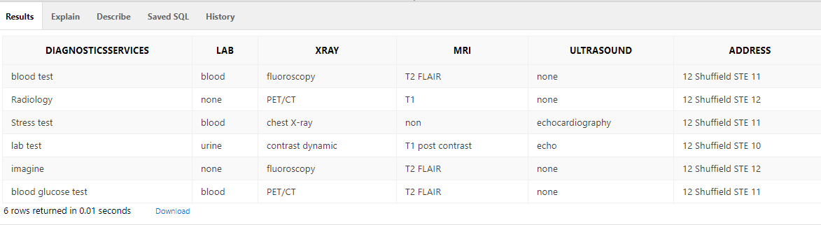

drop table doctor cascade constraints;

create table doctor (

Id number(20) primary key,

gender char(30),

name varchar2(20) not null,

address varchar2(24) references clinic (address),

department varchar2(10),

phone number(15));

insert into doctor values(4532, 'M' ,'Tom Hass','12 Shuffield STE 11', 'Surgery', 5013452345);

insert into doctor values(4782, 'F' ,'Sara Day','12 Shuffield STE 12', 'Oncology', 5013452895);

insert into doctor values(4783, 'F' ,'Rose Dain','12 Shuffield STE 14', 'pediatric', 5013452896);

insert into doctor values(4784, 'F' ,'Raha Ray','12 Shuffield STE 12', 'Radiology', 5013452897);

insert into doctor values(4785, 'M' ,'Dan Day','12 Shuffield STE 10', 'urology', 5013452898);

insert into doctor values(4786, 'M' ,'John Jay','12 Shuffield STE 14', 'gynecology', 5013452899);

SELECT *

FROM doctor;

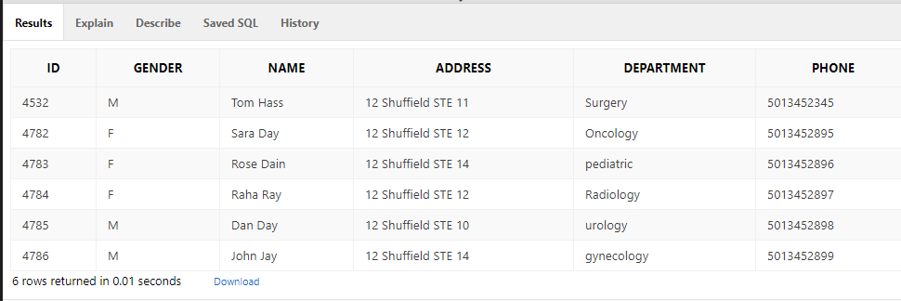

drop table specialistDoctor cascade constraints;

create table specialistDoctor (

Id number(20) references doctor(Id),

specialist varchar2(30),

primary key(Id, specialist));

insert into specialistDoctor values(4782, 'General Surgeon');

insert into specialistDoctor values(4532, 'Oncologist');

insert into specialistDoctor values(4783, 'Pediatrician');

insert into specialistDoctor values(4784, 'Radiologist');

insert into specialistDoctor values(4785, 'Urologist');

insert into specialistDoctor values(4786, 'Gynecologist');

SELECT *

FROM specialistDoctor;

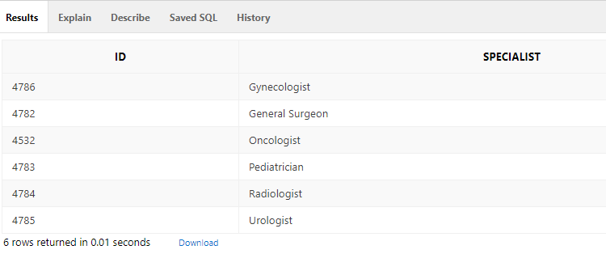

**Design and Implementation**

**Phase 4 – Project**

Select name, specialist, address FROM doctor d, specialistDoctor s where s.id = d.id and d.id=4783 ;

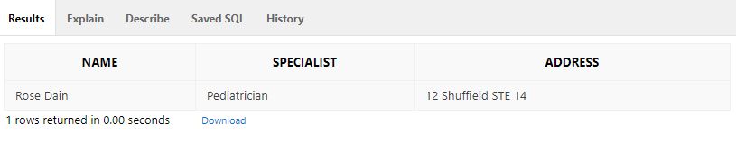

Select name, specialist, address FROM doctor d, specialistDoctor s where s.id = d.id and d.id=4786 ;

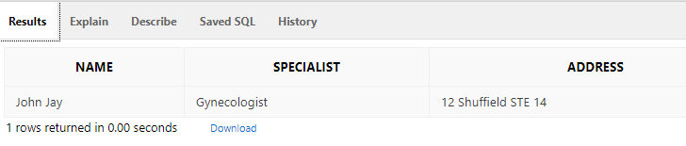

Select problem

from problemInfo where problem='heart attack'

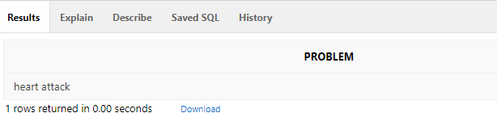

**Trigger:**

create table Drugbackuptable (

testResult varchar2(20),

oldDrug varchar2(20),

newDrug varchar2(20),

dateOfange date);

create or replace trigger DrugupdateTrig

after update of drug

on testResultInfo

for each row

begin

insert into Drugbackuptable values (:old.testResult, :old.drug, :new.drug, sysdate);

end;

DECLARE

BEGIN

insert into testResultInfo values ('High HDL','blood','CholestOff');

END;

Select name, specialist, address,phone FROM doctor d, specialistDoctor s where s.id = d.id and d.id=4532;

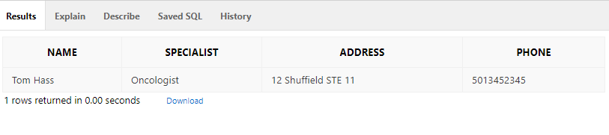

select diagnosticsServices

from provision

where address = '12 Shuffield STE 11';

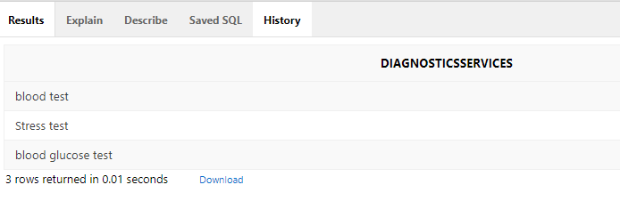

select Name, gender, Specialist

from doctor d, specialistDoctor s

where s.Id = d.Id ;

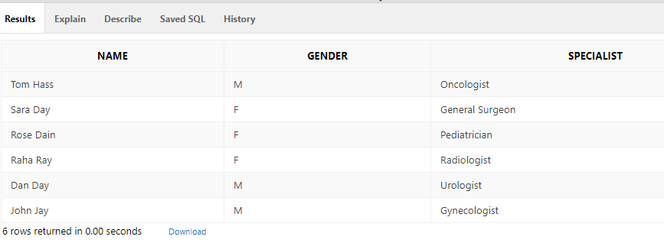

select diagnosticsServices, lab, MRI

from provision

where lab='blood' and MRI= 'T2 FLAIR';

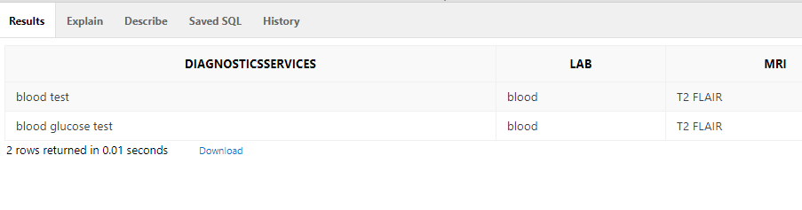

select distinct p.name, p.ID, r.problem, r.recordId

From patientRecord r, patient p

where p.ID = r.PatientID and r.problem = 'heart attack';

